1. **Write a Python Program to Find the Factorial of a Number?**

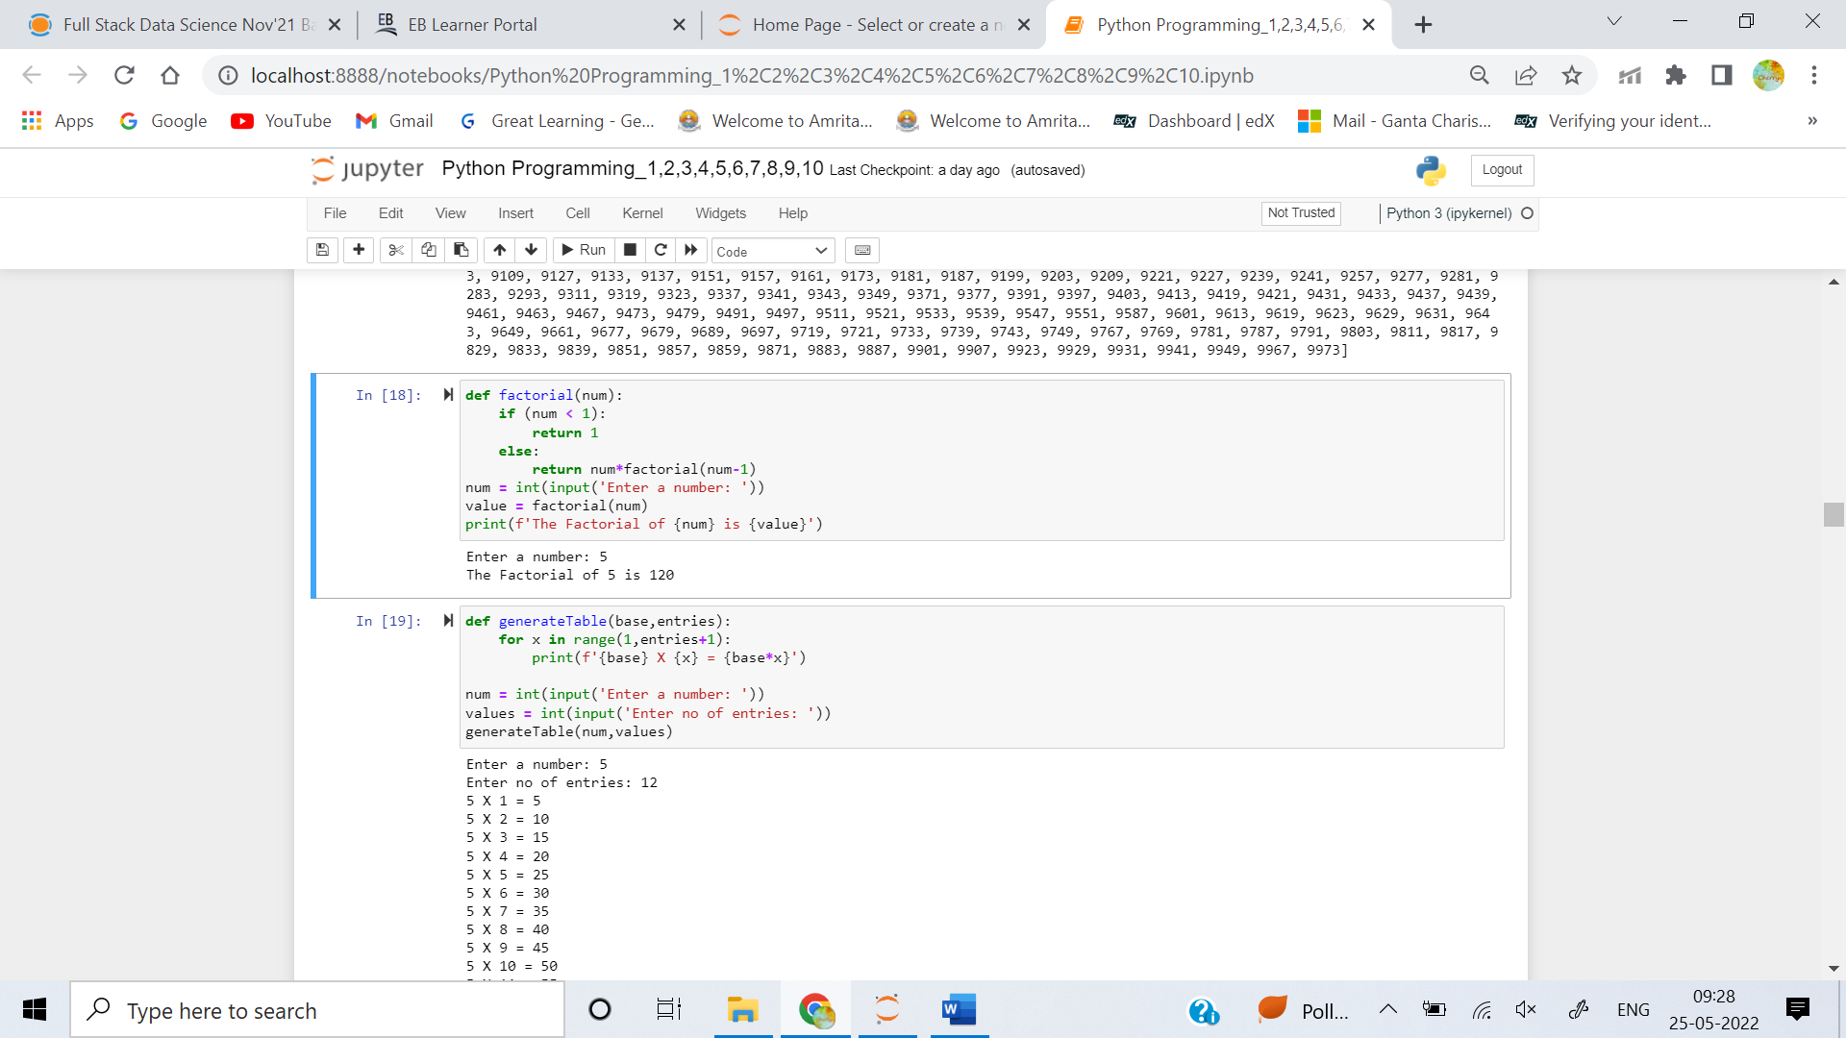

1. **Write a Python Program to Display the multiplication Table?**



1. **Write a Python Program to Print the Fibonacci sequence?**

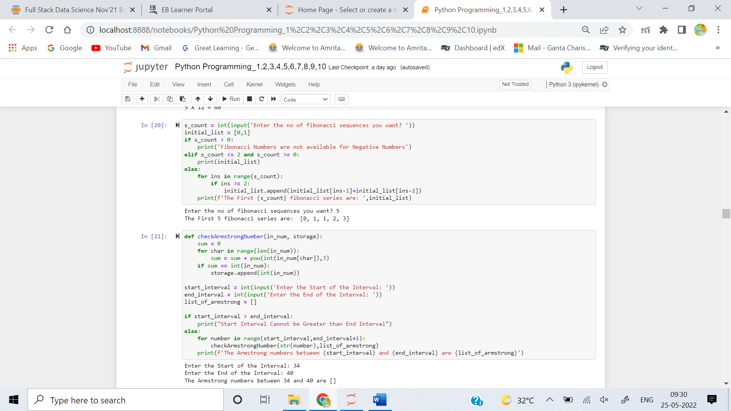

1. **Write a Python Program to Check Armstrong Number?**

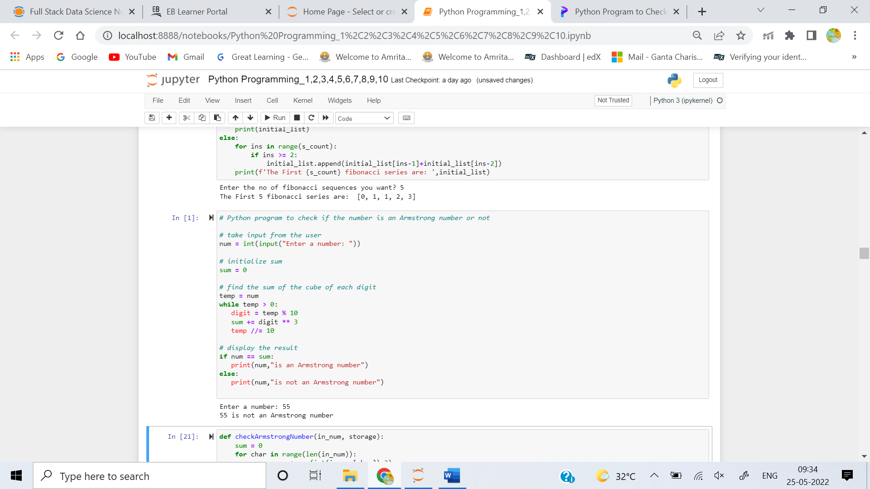

1. **Write a Python Program to Find Armstrong Number in an Interval?**



1. **Write a Python Program to Find the Sum of Natural Numbers?**

